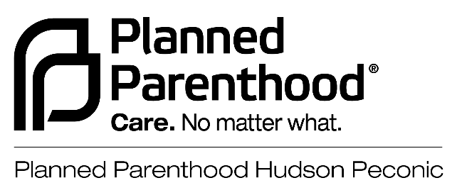.

INTERNSHIP DESCRIPTION

Title: Advocacy and Government Relations/Community Outreach Intern

Division: External Affairs

Department: Advocacy and Government Relations

Supervisor: Manager of Advocacy and Student Programs

Status: Intern
_______

Position Summary:
- Provides administrative and workflow support for all departments as they pertain to Advocacy and Government Relations.

Primary Responsibilities:
To support all affiliate advocacy and government relations efforts, specifically:

- Conducts appropriate research for a variety of advocacy and government relations efforts.

- Participates in scheduling, appointments, and conference calls.

- Participates in tabling for college events, community/street festivals, health fairs with PPHP; canvassing (crowd and targeted neighborhoods), phone banking

- Assists in the recruitment, coordination, and mobilization of volunteers for actions, lobby meetings, rallies, canvassing, tablings, etc.
- Supports planning and implementation of specific issue or advocacy campaigns and related events.
  - Examples: Civic engagement; voter registration, abortion access, Patient Advocacy Programs

- Assists Advocacy and Government Relations staff in all department efforts including special projects, internal and external communications, and interdepartmental projects, including external coalitions and groups.

- Assists in monitoring and tracking local media (clip & distribute news articles on reproductive health, politics, sexuality, etc.).

- Works to gain greater knowledge of sexual and reproductive health, rights, and freedom issues.

- Other projects and duties as required or assigned by Advocacy and Government Relations staff.

- Assists Advocacy and Government Relations staff in all department efforts including special projects, internal and external communications, and interdepartmental projects.

Qualifications:

- Student seeking a Bachelor’s degree in Women’s Studies, Sociology, Political Science, Marketing, Communications, or related field.

- Commitment to the mission of Planned Parenthood.

- Excellent organizational, administrative, and writing skills.

- Basic knowledge of computer systems and software, including Microsoft Office Suite.

- Understanding of the internet as a resource for research and communication.

- Strong interpersonal skills and ability to work as part of a team with staff and volunteers or independently. Attention to deadlines and confidentiality with content sensitive material in accordance with HIPAA regulations.

- Assertive, detail-oriented, and able to manage several projects simultaneously with thorough follow-up.

- Complete in-person interview, background check, and mandatory trainings.

- Attend regularly scheduled 1-on-1 supervision with Manager of Advocacy and Government Relations.

- Spanish proficiency is recommended, but not required.

Time Commitment

- Full Academic Year: mid-August through mid-May
  - *Complete in-person interview, background check, and mandatory trainings. Internship Orientation with Advocacy and Government Relations Team will be scheduled before you begin*

- Minimum Commitment: Full Academic Year, including Winter Intersession; 10-month commitment (August through May), 12-15 hours per week.
  - Occasional possibility of substituting with evening and/or weekend event attendance on a support level basis.
  - Hybrid remote and in-person activities
    - Most hours will be completed virtually (subject to change)
    - All in-person activities will include COVID-19 safety precautions

- Miscellaneous: Must comply with PPHP policies, with high priority on compliance with confidentiality and social media policies.

- Compensation: Interns are encouraged to arrange to obtain college credit for the internship. Financial compensation is dependent on available funds and may differ from previous or future internships.

Employee signature |  | Date

Approved by:
Division Head: |  | Date
Human Resources: |  | Date

